FACULTY PROFILE

Mr. AKHIL K SREEDHAR 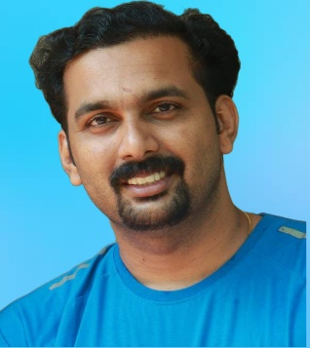
Assistant Professor & Head
Department of Physical Education
PRNSS College, Mattanur
Email : akhilksemail@gmail.com
Mob : 9496259053

Current Professional status

● Assistant Professor and Head of the Physical Education Department

Academic Bodies/ Duties of Universities

- Selector, Kannur University Men and Women Handball Team
- Selector, Kannur University Men Softball Team.
- Selector, Kannur University Men and Women Volleyball Team.
- Additional Examiner of Kannur University

Academic qualifications

- UGC – NET in Physical Education
- M Phil in Physical Education
- M.P.Ed
- B.P.Ed
- BA Economics
- Certificate Course in yoga and Fitness
Duties Performed
- Chief Examiner of Calicut University
- University Exam Invigilator
- Election Returning Officer
- Sectoral magistrate –Quarantine Violation
- Question Paper Setter of MG University
- Question Paper Setter of Christ College Iringalakkuda (Autonomous)

Responsibilities Undertaken
- Coordinator Sports Club
- Deputy Warden-Men’s Hostel
- President Drama Club
- Member Staff Council
- Member IQAC
- Member Anti Ragging Cell
- Member Purchase Committee
Areas of Academic Interest
- Volleyball Training and Teaching Officiating part
- Teaching and Training of Yoga
- Teaching and Training of First Aid

Papers presented in International Symposia

- Attended and Presented 2 paper in International Conference

Papers presented in National Seminars

- Attended and Presented 4 paper in National Conference

Refresher/ Orientation Programmes Attended

- Attended Refresher Course from Academic Staff College, Kannur University Duration- 14 days
(12-02-2020 TO 25-02-2020)

- Attended Orientation Course from TLC Ramanujan College, University of Delhi under the aegis of Ministry Of Education Pandit Madan Mohan Malaviya National Mission On Teachers And Teaching
(20-01-2023 TO 18-02-2023)

Publications

- Publication in Journals – 1
- Chapters in Edited Volumes – 2

Achievements

- Third Rank in Kannur University M.P.Ed Examination
- Qualified official in Volleyball
- Represented Kannur University in All India/South zone Softball and volleyball Tournaments
- State Volleyball Championship Participation in Junior, Youth and Senior Category

