Faculty profile
1 Name of the faculty (in capital letters) : ANAGHA P
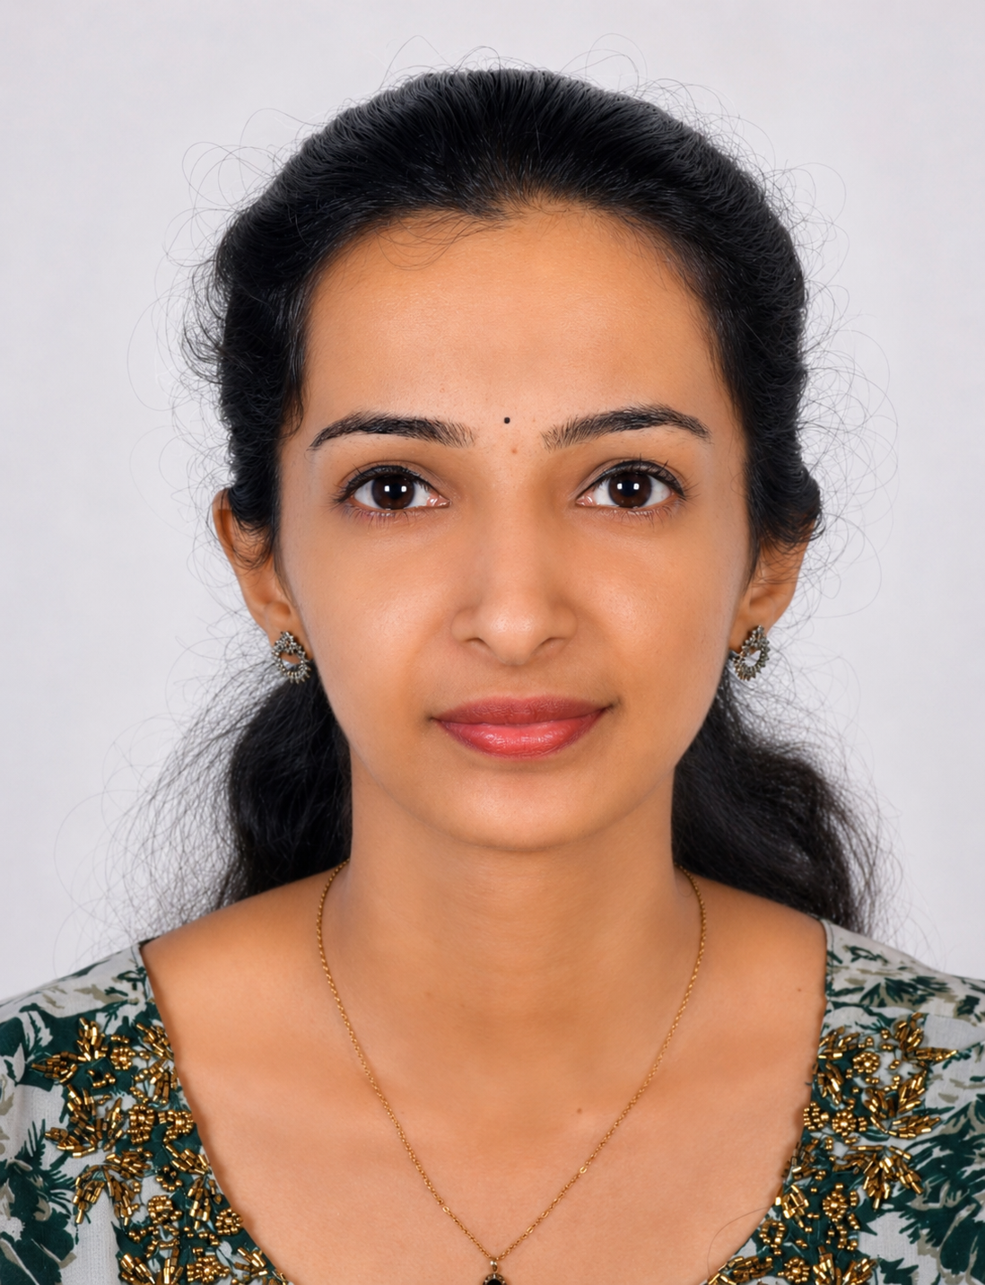

Photo
2 Designation : Assistant Professor (on contract)
3 Mobile number : 9497577638
5 Email : anaghasatheeshan78@gmail.com
6 Date of Birth (DD-MM-YYYY) : 29/03/1999
7 Date of Joining (DD-MM-YYYY) : 08/06/2026
8 Date of Retirement (DD-MM-YYYY) : 31-03-2027
9 Teaching Experience (Years) (as on June 2026) : 3
10 Profile Photo to be Updated in website (Yes/No) : Yes
11 Address
Permanent Address | Communication Address
Padinhare house  (PO) Vadakkumbad, Madathumbagam  Thalassery  670105 | Padinhare house  (PO) Vadakkumbad, Madathumbagam  Thalassery  670105

12 Educational Qualifications
Sl. No | Education | University | Year of Passing | Specialisation (if any)
1 | BSc | Kannur university | 2019 | Mathematics
2 | MSc | Kannur university | 2021 | Statistics
3 | SET | Director General of Education | 2021 | Statistics
4 | NET | UGC | 2024 | Population Studies

13 Teaching experience
Sl. No | Month & Year From | Month & Year to | Organisation | Designation
1 | 08/06/2026 |  | PRNSS College, Mattanur | Assistant professor(on contract)
2 | 09/06/2025 | 31/03/2026 | PRNSS College, Mattanur | Assistant professor(on contract)
3 | 12/06/2024 | 27/03/2025 | PRNSS College, Mattanur | Assistant professor(on contract)
4 | 07/08/2023 | 30/09/2023 | Govt. Brennen College | Assistant professor(on contract)
5 | 01/10/2021 | 30/04/2022 | MG Arts & Science College,Chendayad | Assistant professor(on contract)

14 Workshops Attended
Sl. No | Title of Workshop | Organising Institution | Venue (Online/Offline) | Duration (From –To)
1 | Research methodology & hands on training on data analysis using SPSS | KSHEC | Offline | 24-02-2025 to  25-02-2025
2 | Three day online R Workshop | STATUP | Online | 20-02-2026 to  23-02-2026

15 Seminars/ Webinars attended
Sl. No | Title of Seminar/ Webinar | Organising Institution | Venue (Online/Offline) | Date/ Duration (From–To) | Level (State/National/ International)
1
2
3
4

16 Orientation courses attended
Sl. No | Title of Course | HRDC / MMTTC & University | Duration (From–To)

17 Refresher courses attended
Sl. No | Title of Course | HRDC/MMTTC & University | Duration (From–To)
1
2
3
4

18 Short term courses attended
Sl. No | Title of Course | HRDC/MMTTC & University | Duration (From–To)
1
2
3
4
5
6
7

19 Seminars organised
Sl. No | Title | Date/ Duration (From–To) | Level (State/ National/International)
1
2
3

20 Responsibilities Undertaken (Eg. IQAC Coordinator, Admission Committee member, NAAC Coordinator, Timetable Committee, NSS Programme Officer, Examination committee, Internal exam coordinator etc.)
Responsibility/Position | Committee/Cell | From–To
Member | Dept. Internal & Model Exam | 12-06-2024 onwards

21 Memberships in Professional Body ( Eg. Indian Accounting Association (IAA), Indian Commerce Association (ICA) etc.)
Professional Body | Membership No. | Type | Year

22 Research publications
Title | Books / Journal Name | Publisher | ISSN/ISBN | Volume, Issue, Pages | DOI | Year

23 Paper presentations
Paper Title | Conference name | Organiser | Date | Level | Mode

24 Area of interest

25 Examinership ( Question Paper Setter, Additional Chief Superintendent, Chief Superintendent,
Invigilator, Additional examiner, Chief examiner, Practical Examiner, Project Evaluation etc.)
Question paper setter Model Exam, Additional Examiner University Exam,

26 Duties performed (Admission Duty, Census Duty, Election Duty, NAAC documentation, IQAC activities, NSS camp, Examination Duty, University Valuation, Internal Audit)
Duty | Duration | Remarks
Examination duty  University Valuation | 2024 onwards  2024 onwards | University & Model Exam  University Exam

27 Subjects handled
Statistics, Probability Theory

28 Awards and Honours
Name of Award | Awarding Agency | Level ( College/ University/ State/ National/ International) | Date/Year | Purpose

29 Books published
Title | Publisher | Edition | Publication Year | Type ( Textbook/ Reference/ Edited Book)

30 Ph.D./M.Phil/PG Project Guidance
Scholar Name | Degree (Ph.D./ M.Phil.) | University | Research Title | Status ( Completed/ Ongoing) | Year (Award/Registration Year) | Role (Guide/Co-guide)

31 Resource Person Assignments
Programme (Workshop/FDP/Seminar etc.) | Topic | Organising Institution | Date | Level College/ State/ National/ International | Mode( Online/ Offline)

32 Academic Bodies/BoS MembershipBoard of Studies Member; Academic Council Member; Research Committee Member; IQAC Member; University Curriculum Committee
Academic Body | Position ( Chairperson/ Member/ External Expert) | From | To

33 Any other relevant information
Activity/Achievement | Description | Year

