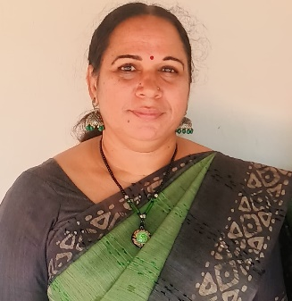
Dr.Radhamani.C.P
Hrithus Villa,Velliyamparamba
Mattannur college P.O
Mobile:8848904719
Email: radhamanicp1@gmail.com
Education
Ph.D in History ,SSUS,Kalady
`M.Phil in History,SSUS,Kalady
M.A History,SSUS,Regional Centre,Payyanur
B.A History,KMM Government Womens College,Kannur
Teaching Experince
Assistant Professor,NSS Hindu College,Changanassery (2009 to 2013)
Assistant Professor,PRNSS College,Mattannur (2013-2021)
Associate Professor, PRNSS College,Mattannur (2021- )
Orientation Programme: Participated 13 day Orientation Programme at Kannur University
Refresher Course: Attended two Refresher Course
Short Term Course : Participated one short term course organized by KSHEC
Conferences and Seminars: Attended twelve National Conferences, ten International Conferences , 5 regional seminars and seven workshops.
Position held:
At College level
Additional Superintendent, University Exam
Co-Ordinator ,WWS
Member,IQAC
` Scholarship,Nodal Officer
NSS Pogramme Officer
Member,PTA Exicutive
College Union Election,Convenor
SFA, FYUG Monitoring Committee
At University level
BOS, Member,History
University Exam Squad,Member
FYUG Question Paper settler for B.A History
Faculty of History

